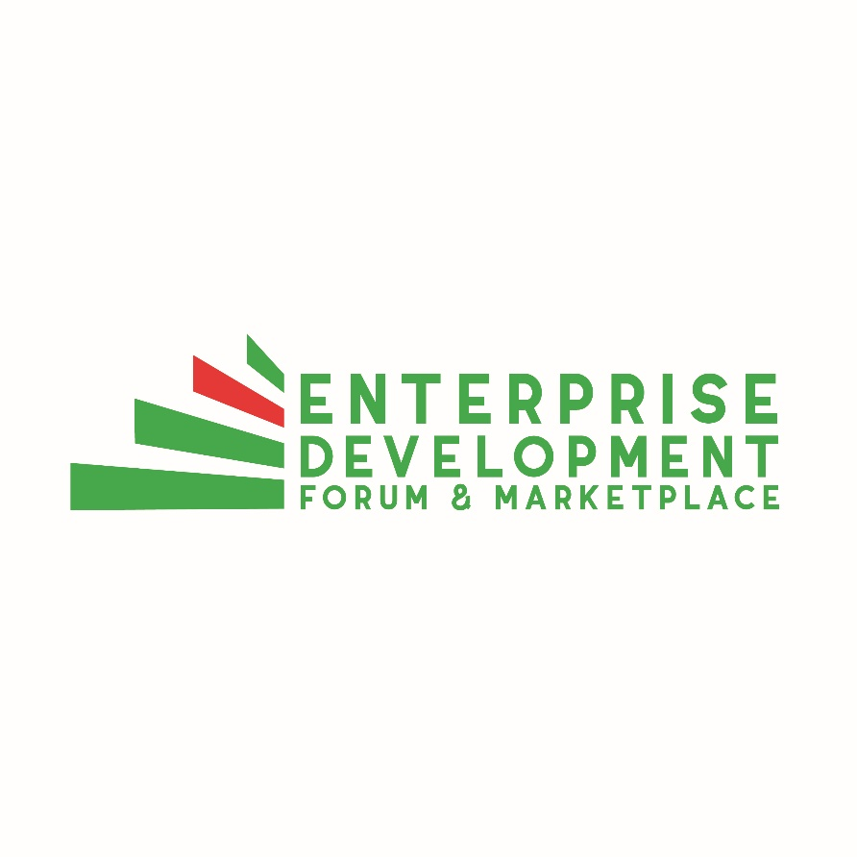
Press Release
To: All Media
Date: April 5th, 2018
Re: Enterprise Development Event Confirms Wes Hall as Special Guest Speaker

Rodney Bay, Saint Lucia (April 5th, 2018): The organizers of the upcoming Enterprise Development Forum & Marketplace, June 13 & 14 are excited to announce that Canada based business man, Executive Chairman and Founder of Kingsdale Advisors Mr. Wes Hall, will be the Special Guest Speaker. He will join a lineup of experts who will discuss some of the key issues affecting the region.

Mr. Hall is no stranger to the world of mergers and acquisitions and joins the diverse team of industry experts alongside the most recent inductees representing the USAID and the Carbon War Room. He will engage the attendees on the emerging industries and the best moves to achieve success abroad. With business interests in the region including the newly opened Harbor Club Curio Collection by Hilton in Saint Lucia, Mr. Hall has close ties to the region and brings a wealth of experience and information as it relates to the business environment. He is also the owner of QM Environmental, a leading environmental and industrial services provider and Titan Supply, a leading manufacturer and distributor of rigging and wear products serving industries in the oil, construction and transportation sectors.

Attendees can still take advantage of the early bird special of US$175 until April 15th 2018, for a full access pass to the two-day event comprising of the morning forums featuring expert speakers, afternoon marketplace sessions and break out meetings. Non-speakers can also participate in the marketplace exhibition for US$550. For more information, email info@enterprisedevelopmentforum.com, visit us on Facebook and LinkedIn @enterprisedevelopmentforum or browse our website on www.enterprisedevelopmentforum.com for the latest updates.

For more information, please contact:
Kezia Preville/Nerdin St. Rose
Event Organizers
(T) 714-4882/713-9191
(E) info@enterprisedevelopmentforum.com

